**Port E at address $00400008**

Connected to the inner (left most) 40 pin expansion header on the DE2 (see below). Check DE2 user manual for further info. If you are unsure which pins are which, write a little 68k assembler program to write to or read from the port.

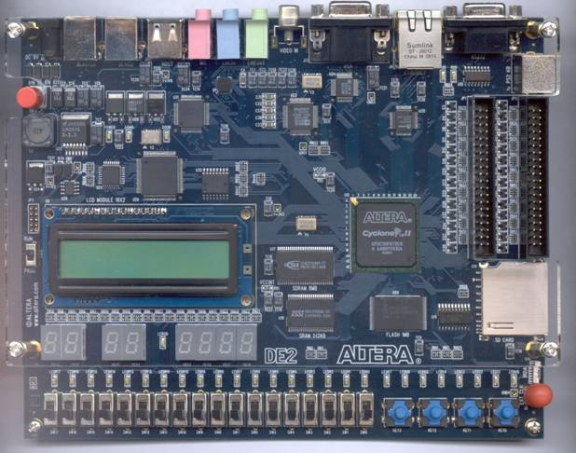 

Input Port E (i.e. read from Address $00400008 e.g. move.b $00400008,d0 )

|  |  |  |
| --- | --- | --- |
| InPortE[7]  InPortE[6]  InPortE[5]  InPortE[4]  InPortE[3]  InPortE[2]  InPortE[1]  InPortE[0] | PIN_T22  PIN_R20  PIN_R24  PIN_R25  PIN_P24  PIN_N24  PIN_M25  PIN_M24 | GPIO_1[15] GPIO_1[14] GPIO_1[13] GPIO_1[12] GPIO_1[11]  GPIO_1[10]  GPIO_1[9]  GPIO_1[8] |



Output Port E (i.e. write to address $00400008, e.g. move.b d0,$00400008)

|  |  |  |
| --- | --- | --- |
| OutPortE[7]  OutPortE[6]  OutPortE[5]  OutPortE[4]  OutPortE[3]  OutPortE[2]  OutPortE[1]  OutPortE[0] | PIN_M21  PIN_N20  PIN_M20  PIN_M19  PIN_M23  PIN_M22  PIN_K26  PIN_K25 | GPIO_1[7] GPIO_1[6] GPIO_1[5] GPIO_1[4] GPIO_1[3]  GPIO_1[2]  GPIO_1[1]  GPIO_1[0] |

